Computational Biology
Faculty Candidate Interview

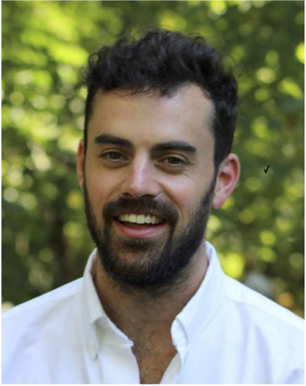
David van Dijk
Yale University, Department of Genetics
Department of Computer Science

"Manifold learning yields insight into complex
cellular state space"

Seminar:
Friday, March 9, 2018
1:30-2:30 pm
TAC Auditorium

